**SE Arcade User Guide**

**SE Arcade Launcher**

**June 2021**

**Version 1.0.0.0**

Please read the manual carefully and keep it in mind before using this device.

Put this manual within touch of your reference in anytime.

**TABLE OF CONTENTS Page number:**

**Main Page**……………………………………………………………………………………………....... 1

**Table of Contents**………………………………………………………………………………………. 2

**Warnings and Safety Precautions**……………………………………………………………… 3

Handling the device in a correct manner…………………………………………………………… 3

Protecting the device from damage………………………………………………………………… 3

What to do, and not to do with the device………………………………………………………… 3Abnormal behaviors………………………………………………………………………………….. 3

**System requirements**………………………………………………………………………………… 4

Recommended Configurations………………………………………………………………………. 4

Minimum Requirements……………………………………………………………………………… 4

Other Requirement Tips……………………………………………………………………………… 4

**General Information of Software**………………………………………………………………. 5

**Account System**…………………………………………………………………………………………. 5

How to login…………………………………………………………………………………………… 5

How to make/edit an account………………………………………………………………………. 5

**Installation**………………………………………………………………………………………………… 6

First time setup……………………………………………………………………………………….. 6

Reinstalling……………………………………………………………………………………………. 6

**Usage Guide**………………………………………………………………………………………………. 6

Introduction…………………………………………………………………………………………… 6

Menu Pages…………………………………………………………………………………………… 6

Hori Fighting Stick Controls………………………………………………………………………….. 7

Known Issues………………………………………………………………………………………….. 7

Good-To-Know………………………………………………………………………………………… 7

**Building Details**…………………………………………………………………………………………. 8

**WARNINGS AND SAFETY PRECAUTIONS**

**For safety Reasons.**

The following suggestions should be adhered to:

**Certain procedures require a qualified person that have experience with the device. For such instructions, a qualified person must take care of the jobs.**

* *Otherwise, an electric shock, device trouble, or a serious accident may result.*
* *Replacing the device’s parts, inspecting, and maintaining the device, and troubleshooting must be assigned only to a qualified person that have experience with the device, such as an adult.*

**Be sure to consult an experienced adult when setting up, moving, or transporting this product.**

* *This product should not be set up, moved, or transported by anyone other than an experienced adult.*
* *When installing this product, do not apply undue force on movable parts. Otherwise, injury and accident may result, or the product may be damaged.*

**Protect the device from:**

* *Rain or moisture.*
* *Direct sunlight.*
* *Direct heat from air-conditioning and heating equipment, etc...*
* *Hazardous flammable substances.*
* *Otherwise, an accident or malfunction may result.*

**Important Warnings and Notices:**

* *The device for indoor usage only does not install outside.*
* *Do not set the device up near emergency exits.*
* *Do not place containers holding chemicals or water on or near the device.*
* *Do not place objects near the ventilating holes.*
* *Do not bend the power cord by force or place heavy objects on it.*
* *Never plug or unplug the power cord with wet hands.*
* *Never type BARRY with the controller on the launcher.*
* *Never unplug the game device by pulling the power cord.*
* *Be sure to use indoor wiring within the specified voltage requirements. For extension cord, use the specified rating or more.*
* *Be sure to use the attached power cord.*
* *Never plug more than one cord at a time into the electrical receptacle.*
* *Do not lay the power cord where people walk through.*
* *Be sure to ground this product.*
* *Do not exert excessive force when moving the device.*
* *Do not alter the system related dipswitch settings.*

***If there is any abnormality such as smoke, bad smell or abnormal noise being emitted from the device, immediately turn OFF the main power switch and unplug the power cord from the receptacle to stop operating it.***

* *Using the device in abnormal conditions could result in fire or accidents.*

**SYSTEM REQUIREMENTS**

***Recommended Configurations:***

*We recommend systems that meet or exceed the following specifications:*

***Processor (CPU):*** *Intel Core i5 (sixth generation or newer) or equivalent*

***Graphics Processor (GPU):*** *GeForce GTX 1060 (Or AMD that is equivalent)*

***Memory:*** *8 GB RAM*

***Storage:*** *512 GB internal Solid-State Drive (SSD) or 1 TB internal HDD*

***Operating System:*** *Microsoft Windows 10 Professional x64*

***Monitor/Display:*** *24" LCD monitor (1920 x 1080)*

***Minimum Requirements:***

*We support the following minimum computer configurations.*

***Note:*** *The following lists minimum requirements that allow for network connectivity and other basic functions. If you are planning on purchasing a new computer, please use the recommended configurations above.*

***Processor (CPU):*** *Intel Core i3 (sixth generation or newer) or equivalent*

***Graphics Processor (GPU):*** *GeForce GTX 750 (Or AMD that is equivalent)*

***Memory:*** *4 GB RAM*

***Storage:*** *250 GB internal storage drive*

***Operating System:*** *Microsoft Windows 10 x64*

***Monitor/Display:*** *15" LCD monitor (1920 x 1080)*

***Other Requirement Tips:***

**Any other system that can perform well enough to run simple emulations will be the best standard for this device. But the recommended configurations are optional but is highly recommended if the owner of the device is planning on playing more modern games on the device.**

* *Older games, older hardware.*
* *Newer games, newer hardware.*

**GENERAL INFORMATION OF SOFTWARE**

*The software provided is made so that it locks the computer down, to prevent people from accessing the system as an administrator. To unlock the computer, you must login and provide a valid administrator username and password.*

*The software is not required for the system to function, it is just a good way of managing the games and emulators that is executed on the system.*

**ACCOUNT SYSTEM**

***How to login:***

*The software contains a default administrator account that can be modified. Please do not delete this account as it can cause issues in the future. (Always have an administrator account that you know the username and password of)*

***Default Administrator Username:*** *admin* ***Default Administrator Password:*** *admin*

1. *To open the login prompt, you must click the profile picture in the top left corner.*
2. *Enter the desired username and password in the correct textboxes.*
3. *Click proceed.*

*Administrator accounts gain access to additional features such as.*

* *Manually add games by path.*
* *Scan for steam games.*
* *Removing games.*
* *Shut down software to access the rest of the system.*

***How to make/edit an account:***

*First you need to login as an administrator to gain access to the system. This way you can modify the “Accounts.json” file that contains all the information about the current accounts. This file can be found in the folder named “Accounts”.*

1. *Open “Accounts.json” file.*
2. *Edit the JSON data to match your preferred account settings.*
3. *Save the file.*

**INSTALLATION**

***First time setup:***

**When launching the software for the first time, there will be an installation process:**

* *Software will set itself to launch on startup.*
* *Software will download and install necessary packages to optimize performance.*
* *Software will setup all settings to make the user experience the best as it can be.*

***Reinstalling:***

**If issues happen (which can occur) it might be a good idea to fully reinstall the software. You can find all needed files on the official GitHub Repository (**<https://github.com/Zebratic/SE-Arcade-Launcher/releases>**)**

**[Do not download the “EXE to autoupdate to” file]**

1. *Download all files from GitHub.*
2. *Delete old files.*
3. *Replace the old files with the new downloaded ones.*
4. *Launch “SE Arcade Launcher.exe” to begin the first-time setup.*

***WARNING:***

* *DO NOT FORMAT/REINSTALL WINDOWS/HARDDISKS AS IT CAN CAUSE THE CONTROLLER DRIVERS TO INSTALL A DEFAULT DRIVER, WHICH IS NOT COMPATIBLE WITH THE LAUNCHER!*

**USAGE GUIDE**

***Introduction:***

* *On launch, the user will watch a short 10-15 second startup intro. After that, the user will see the main launcher. It will start on the Controls page showing the controls for the Hori Fighting Stick for Nintendo Switch. This is to quickly teach the user how to manage the menu.*

***Menu pages:***

* *Games*
  + *Here you can find all the games that have been added to the launcher.*
  + *You can edit the game data by right clicking the game using a mouse and keyboard.*
  + *Here you can Add, Remove and Scan for new games.*
* *Controls*
  + *Here you can find a schematic of the Hori Fighting Stick controller.*
* *Credits*
  + *Here you can see who contributed to create the software and Device.*
* *Performance*
  + *Here you can monitor current Processor (CPU) and Memory (RAM) usage.*
* *Settings*
  + *Here you can manage all settings for the controller and external PS3/PS4 controllers.*

***Hori*** ***Fighting Stick Controls:***

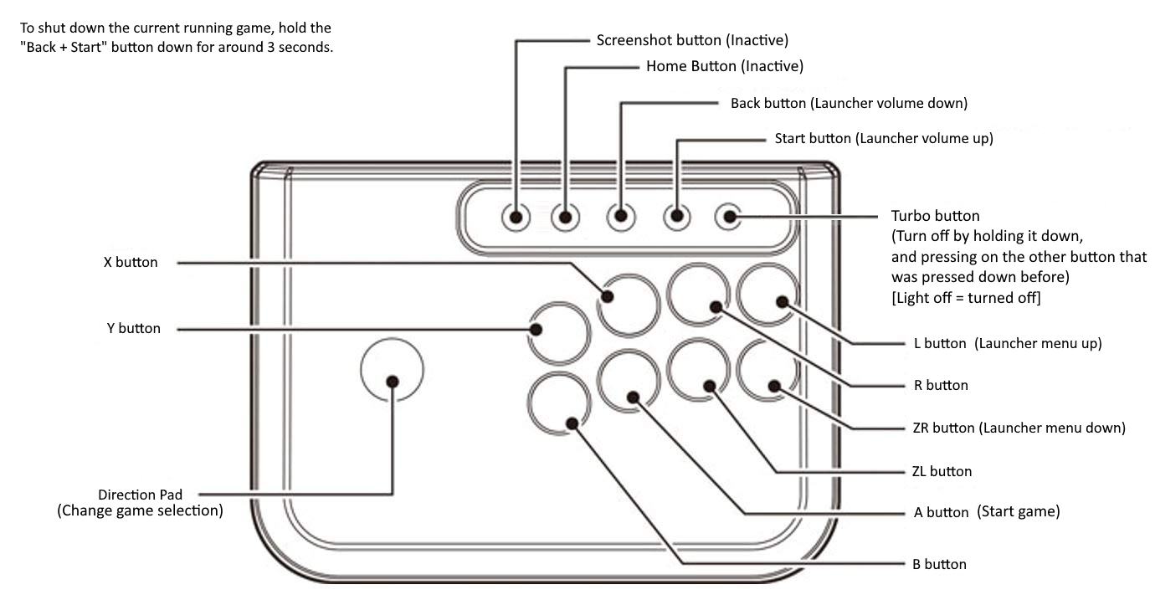

*On the schematic you can see all the controls for the inbuilt controllers. Text inside* *parentheses is when on the menu, and not inside a game.*

***Known Issues:***

* *If the controllers do not work on the launcher on startup, unplug both controller USB cables and plug them back in. (The right controller is the one that should be able to interact with the launcher, if not plug the USB’s back in, in a different order)*
* *When removing a game from the launcher, it is recommended to restart the launcher as it can cause issues with the game selection.*
* *If any type of anti-virus is installed on the system, it can cause issues with the launcher software, or games installed. (Always have anti-virus uninstalled or disabled fully)*
* *If the device does not have any internet connection, it can cause issues with the auto updating feature, and other games that have online play.*
* *When typing button combos on the controllers, please do it slowly and steady, to avoid double clicking.*

***Good-To-Know:***

* *To quickly shut-down the current running game, hold down the “+” and “-” button for 3 seconds.*
* *To login, edit games, and other administration, you can access the built-in keyboard and mouse by opening the front panel right under the controllers.*
* *You can open the back panel of the Arcade to access the computer system and all the other components.*
* *If the controllers do not work on the launcher on startup, unplug both controller USB cables and plug them back in. (The right controller is the one that should be able to interact with the launcher, if not plug the USB’s back in, in a different order)*
* *Make sure the system “always” has an internet connection, wither Ethernet or Wi-Fi. (Device comes with a Wi-Fi dongle)*

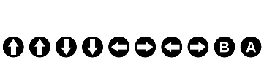

**BUILDING DETAILS**

***Head Developer and Software Engineer:***

* *Alexander Molberg Christiansen*

***Head Builder:***

* *Frederik Højvang*

***Builders:***

* *Alexander Molberg Christiansen*
* *Frederik Højvang*
* *Mikkel Korshøj Jensen*
* *Henrik Wieck-Nordahn*
* *Jannick Christensen*
* *Yolande Torbensen*
* *Jeppe Holst Wagner*
* *Albert Kaag Cappelen*

***Designers:***

* *Frederik Højvang*
* *Oliver Schultz Bach*
* *Yolande Torbensen*

***Electricians:***

* *Alexander Molberg Christiansen*
* *Jeppe Holst Wagner*

***Play Testers:***

* *Alexander Molberg Christiansen*
* *Frederik Højvang*
* *Henrik Wieck-Nordahn*
* *Frederik Østerhaab*
* *Bjarke Holmer Lund*

***Emotional Support:***

* *Isak Gjedbo*
* *Jens Andersen-Mølgaard*

**For any help, or assistance with software / hardware related issues please contact the Head Developer and Software Engineer for help.**

**Contact at any of the given emails:**

* [*alex758c@gmail.com*](mailto:alex758c@gmail.com)
* [*alexandermolberg@gmail.com*](mailto:alexandermolberg@gmail.com)
* [*zebraticyt@gmail.com*](mailto:zebraticyt@gmail.com)